Driving Marketing Efficiency: A Case Study in User-Centric Ad Development for Butterfly Learnings

From Feedback to Conversion: How User Insights Slashed CPL by 66% for Butterfly Learnings

This case study examines how a strategic, user-centric approach to advertising, informed by direct feedback, surveys, and social media interactions over a two-year period, enabled Butterfly Learnings to significantly reduce its Cost Per Lead (CPL) from ₹900 to approximately ₹300. While the provided ad creatives showcase the output of this user-driven strategy, the insights into the feedback collection process and the specific CPL reduction figures are drawn directly from our conversation history.

The Challenge: High Cost Per Lead

Initially, Butterfly Learnings faced a high Cost Per Lead (CPL) of ₹900. This indicated that the existing marketing efforts might not have been optimally resonating with the target audience, leading to inefficient lead generation. The objective was to create more impactful and relevant advertisements that would attract higher-quality leads at a lower cost.

The Strategy: User-Driven Ad Development

The core of the strategy involved an iterative process of gathering and integrating user feedback, suggestions, surveys, and social media interactions over two years. This deep dive into parental concerns, needs, and pain points informed the messaging and visual elements of subsequent ad campaigns. The resulting advertisements, as depicted in the provided sources, reflect a clear understanding of the target audience's priorities and anxieties regarding child development therapy.

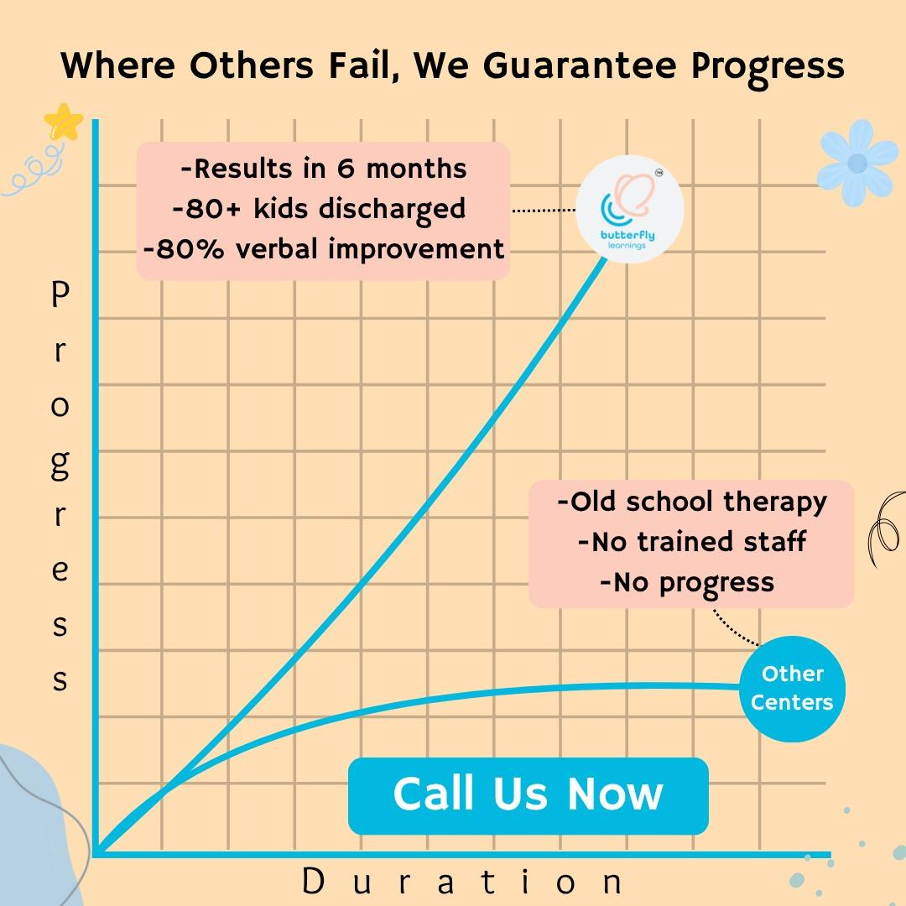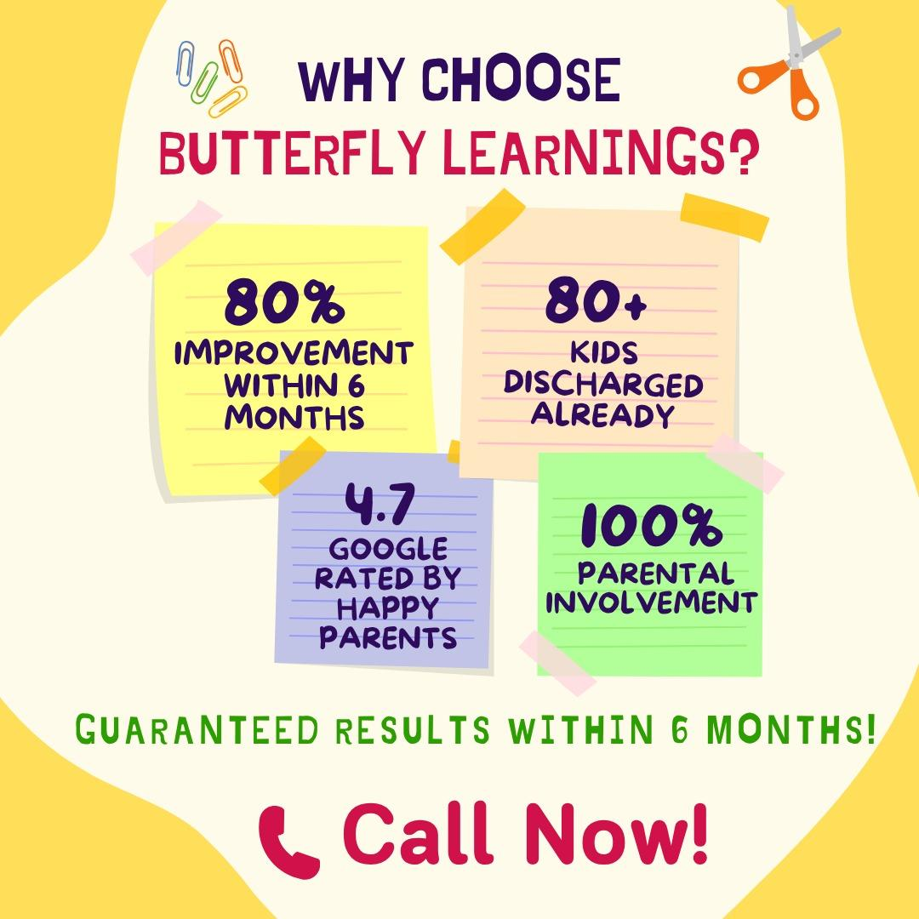

Key Pillars of the User-Centric Ad Strategy:

The analysis of the developed ad creatives reveals several strategic messages, likely crafted in direct response to user insights, addressing both explicit and implicit parental pain points:

1. Emphasis on Guaranteed and Quantifiable Progress: Parents seeking therapy for their children often desire clear, measurable outcomes and a predictable timeline. The ads directly address this by prominently featuring a "Guaranteed Progress" promise where "Others Fail" Key performance indicators are clearly stated:

"Results in 6 months".

"80% improvement within 6 months".

"80% verbal improvement".

Evidence of past success is highlighted with "80+ kids discharged" or "80+ children discharged with results". This explicit focus on tangible results and timelines likely resonated strongly with parents, building confidence and urgency, and attracting highly motivated leads.

2. Addressing Core Parental Pain Points Through Solution-Oriented Messaging: While the provided ads do not explicitly list specific parent pain points such as hyperactivity, mobile addiction, aggression, or speech-related issues in a direct "problem-solution" format, the chosen messaging for Butterfly Learnings directly speaks to the underlying concerns associated with these challenges. The strategy appears to acknowledge that parents are seeking concrete solutions to these pervasive issues.

Speech and Communication Related Issues: The ads directly address this common pain point by promising "80% verbal improvement" and listing "Communication skills" as one of the four goals of ABA therapy. This directly targets parents whose children struggle with speech delays or communication challenges.

Behavioral Challenges (Hyperactivity, Aggression, Social Difficulties): Although not explicitly named, these issues are implicitly addressed through the promise of an "EVIDENCE-BASED ABA THERAPY CENTER". Applied Behavior Analysis (ABA) is a well-recognized approach for addressing a wide range of behavioral challenges. The focus on developing "Social skills" directly helps children navigate interactions, which can mitigate aggression and improve behavior often associated with hyperactivity. Furthermore, the goal of improving "Daily living skills" and "Academic skills" implicitly offers solutions for children whose hyperactivity or aggression might impede their ability to learn or perform daily tasks. The contrast with "Other Centers" showing "No progress" likely speaks to the frustration parents experience when behavioral issues persist without effective intervention.
◦
"No Progress" from Other Centers: The ad directly highlights "Old school therapy," "No trained staff," and "No progress" from "Other Centers". This directly addresses the pain point of parents who have tried other therapies without success, offering Butterfly Learnings as the solution for tangible results.

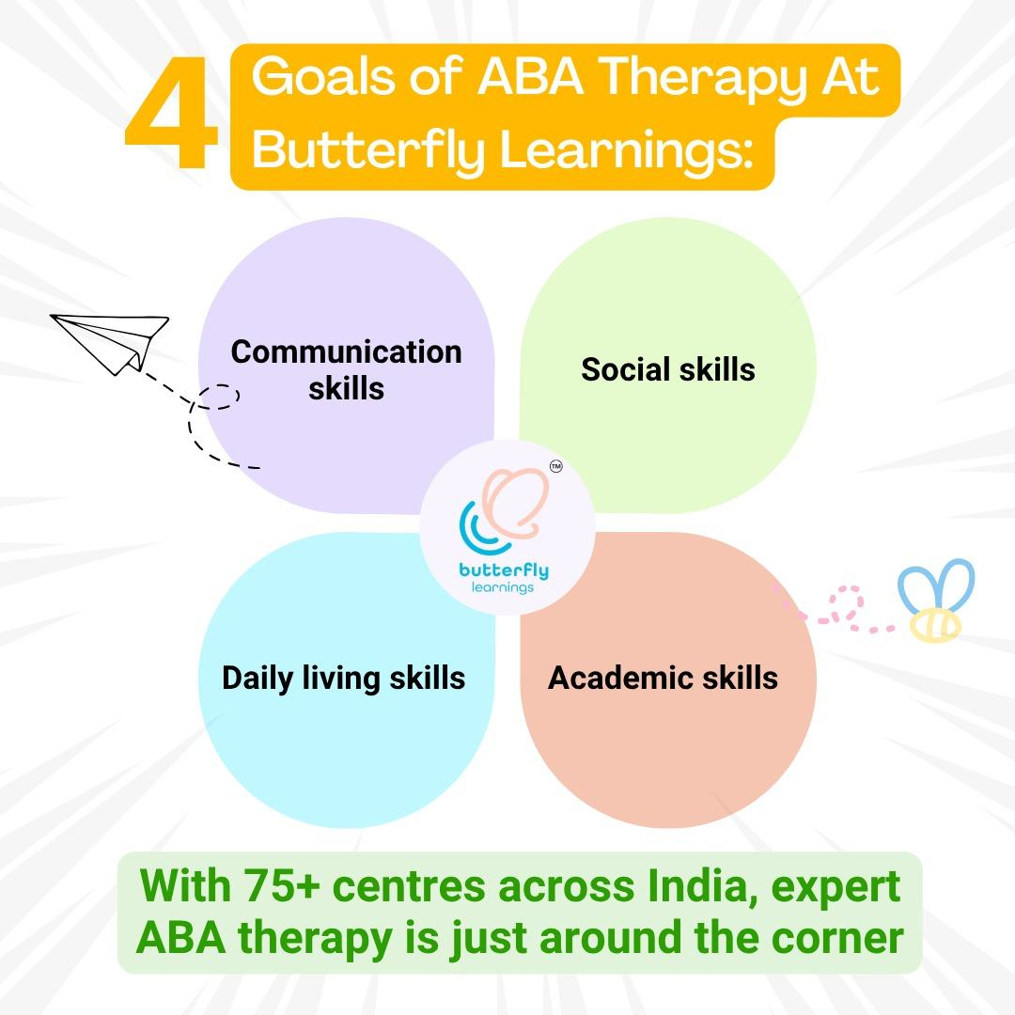

3. Building Trust Through Social Proof and Parental Involvement: User feedback often emphasizes the importance of trust and community validation. Butterfly Learnings leverages social proof by highlighting its strong reputation:

"4.7 Google rated by happy parents". Additionally, the commitment to "100% Parental Involvement" signals transparency and a collaborative approach to therapy. This addresses a common desire among parents to be actively engaged in their child's developmental journey, fostering a sense of partnership and reducing apprehension.

4. Highlighting Evidence-Based Practice and Staff Expertise: A crucial differentiation point is Butterfly Learning's claim to be "India's Only EVIDENCE-BASED ABA THERAPY CENTER". This directly counteracts potential concerns about the efficacy or outdated methods of other centers, which are depicted as using "Old school therapy," having "No trained staff," and showing "No progress". The ads further reinforce quality by stating that "in-school parent awareness sessions" are "Conducted by senior clinical staff". This messaging positions Butterfly Learnings as a credible and scientifically-backed choice, likely appealing to parents who prioritize professional and effective treatment.



5. Addressing Comprehensive Needs and Enhancing Accessibility: The ads demonstrate an understanding of the broad scope of developmental needs, outlining "4 Goals of ABA Therapy At Butterfly Learnings": "Communication skills," "Social skills," "Daily living skills," and "Academic skills". This comprehensive approach assures parents that various aspects of their child's development will be addressed. Furthermore, the expansion efforts indicate a response to the need for greater accessibility:

"With 75+ centres across India, expert ABA therapy is just around the corner".

New offerings like "in-school parent awareness sessions in KHARGHAR" improve local engagement and accessibility for parents. This focus on comprehensive support and widespread availability broadens the potential lead pool and makes the service more accessible, likely contributing to more efficient lead generation.

The Results:

By meticulously crafting advertisements based on accumulated user insights and addressing their core concerns, both explicitly (e.g., verbal improvement) and implicitly (e.g., behavioral challenges through ABA and skill development), Butterfly Learnings was able to significantly optimize its marketing expenditure. The refined messaging and clear value proposition led to a reduction in Cost Per Lead (CPL) from ₹900 to approximately ₹300, representing a substantial 66% improvement in marketing efficiency.

Conclusion:

This case study demonstrates the profound impact of a user-centric marketing strategy. By actively listening to and integrating feedback from its audience over two years, Butterfly Learnings developed highly resonant ad campaigns that not only communicated its unique value proposition effectively but also dramatically improved its lead acquisition cost. The success underscores that understanding and responding to the genuine needs and concerns of the target audience—even if through solution-focused messaging that implicitly addresses specific pain points—is paramount for achieving significant marketing efficiency and business growth.

